Information for students

Preferential voting

About our election
Insert election details (time, date location, positions being elected, contact teacher)

At the polling place
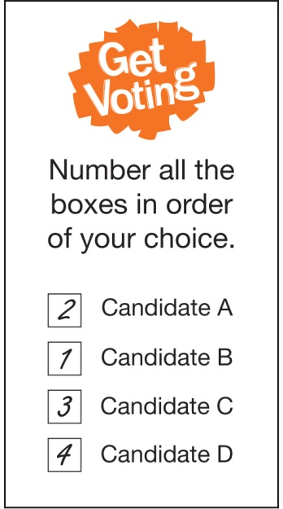
Election officials will give you instructions when you arrive at the polling place. They can also answer any questions you have about the election.
To receive your ballot paper, an issuing officer will ask you three questions:
- What is your name?
- What class are you in?
- Have you voted before in this election?
If you answer ‘yes’ to the last question you will not be given a ballot paper because you can only vote once in each election.

How to Vote
Our school election will use a type of voting called preferential voting.
This is the voting system used in Australian federal elections.
Decide which candidate you think would be best for the position being elected and write the number ‘1’ in the box next to their name. Then write a number 2 next to the name of your second choice. To make your vote count, number every box and only use each number once.
Numbering all the boxes means that if your first choice candidate does not receive enough votes to be elected, your vote can be re-examined and your other choices considered.
Once you have completed your ballot paper, fold it in half and place it in the ballot box.
If you make a mistake, ask an Election Official for another ballot paper and start again.
Remember, your vote is secret. You don’t have to show or tell anyone who you have voted for.

