Information for students

First-past-the-post voting

About our election
Insert election details (time, date location, positions being elected, contact teacher)

At polling place
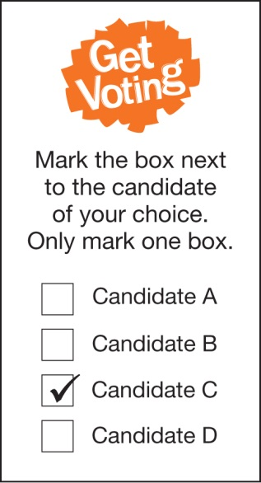
Election Officials will give you instructions when you arrive at the polling place. They can also answer any questions you have about the election.
To receive your ballot paper, an issuing officer will ask your three questions:
- What is your name?
- What class are you in?
- Have you voted before in this election?
If you answer ‘yes’ to the last question, you will not be given a ballot paper because you can only vote once in each election.

How to vote
Our school election will use a type of voting called first-past-the-post. The candidate who receives the most votes will be elected.
Decide which candidate you think is best for the position being elected and mark the box next to the name of that candidate. You can only vote for one candidate, so only mark one box.
If you make a mistake, ask an Election Official for another ballot paper and start again.
Once you have marked your ballot paper, fold it in half and place it in the ballot box.
Remember your vote is secret. You don’t have to show or tell anyone who you have voted for.

